**Sprint 2 Plan - CMPS 115 – Software Methodology**

At the end of your team's sprint planning meeting, the team needs to turn in a sprint plan. This document needs to be typewritten (or the team needs to use a web-based agile planning tool and provide the TA/tutor access to the tool to view the project) and have the following elements:

∙ **Heading:** Document name ("Sprint {number} Plan"), product name, team name, sprint completion date, revision number & revision date.

Hungry Slugs

Sprint 2 Completion Date: 5/7/24

Revision Number: 1.0

Revision Date: 4/24/24

∙ **Goal:** Short, 1-2 sentence description of the high-level goal(s) for the sprint. ∙ **Task listing, organized by user story:** This section lists the user stories, in priority order from most important (top) to least important (bottom). Within each user story, there needs to be a list of tasks required to implement the user story, along with the time estimate for each tasks (preferably less than or equal to 6 ideal hours). This should look like:

US1: As a user, I want to be able to sign in to the platform, so I can keep track of what my preferences are. [5]

1. Use **Figma** to figure out how we want the UI to look. (1 hr)
2. Create a way to rate meals on the backend by creating a foods collection on the database that stores food information and each user rating of that food. (2 hr)
3. Create a login page where users log in/sign up using their UCSC Google account. Collect all user data into a python class. (3 hr)
4. Use **MongoDB** to keep track of all users that use the website. Create a user collection that stores all the users. Be able to pull usernames and favorite foods from a user. (2 hr)
5. Create a user profiles page that displays current known information about the user. Use backend functions to get data on the user. (2 hr)

Total: 10 hours

US2: As a student, I want to be able to find which dining halls are serving my favorite food, so that I know which dining hall to go to. [5]

1. Improve how often the dining hall data is retrieved from the UCSC website. (2 hr)
2. Add a UI to rate the dining hall foods and connect this to the backend. (2 hr)
3. Implement a search bar on the food page for each dining hall that filters food that matches the search query. (3 hr) [Search all dining halls for a specific food. There will be some sort of searching page]

Total: 7 hours

US3: As a student with allergies, I want to be able to filter out the dishes that do not contain dairy, so that I can find food options that fit my dietary preferences. [3]

1. Web scrape the main UCSC website for more data on features of food such as dietary restrictions and ingredients. (2 hr)
2. Add data from new web scraping features to the database structure for the dining halls. Basically store extra info in the food collection. (1 hr)
3. Add more search options like a check box or drop down menu to filter types of food. (1-2 hr)
4. Check the time of day to hide and show certain meals to users. (1 hr)

Total: 6 hours

∙ **Team roles:**

* Ian Holloway: Project Manager / Developer
* Akshat Tiwari: Developer
* Anya Zhang: Developer
* Akhil Senthil: Scrum Master / Developer
* Noah Kim: Developer

∙ **Initial task assignment:** A listing of each team member, with their first user story and task assignment. This should look like:

* Ian Holloway:
  + US1: 1, 2
  + US2: 1
* Akshat Tiwari:
  + US1: 1
  + US2: 3
  + US3: 4
* Anya Zhang:
  + US1: 1, 4
  + US3: 2
* Akhil Senthil:
  + US1: 1, 3
  + US3: 3
* Noah Kim:
  + US1: 1
  + US2: 2
  + US3: 1

∙ **Initial burnup chart:** A graph giving the initial burnup chart for this sprint and is labeled as such with sprint number and project name and is located in the lab.

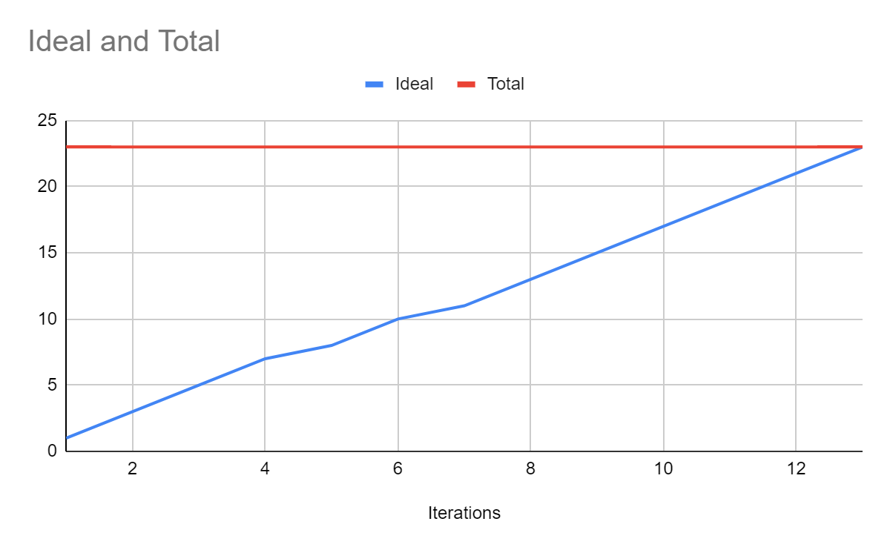

∙ **Initial scrum board:** Also known as a task board, the scrum board is a physical board and labeled as such with sprint number and project name and located in the lab. This board has four columns, titled user stories, tasks not started, tasks in progress, and tasks completed. Index cards or post-it notes representing the user stories and the tasks for this sprint should be placed in the user stories, tasks not started, and tasks in progress columns. Tasks associated with a user story should be placed in the same row as the user story.

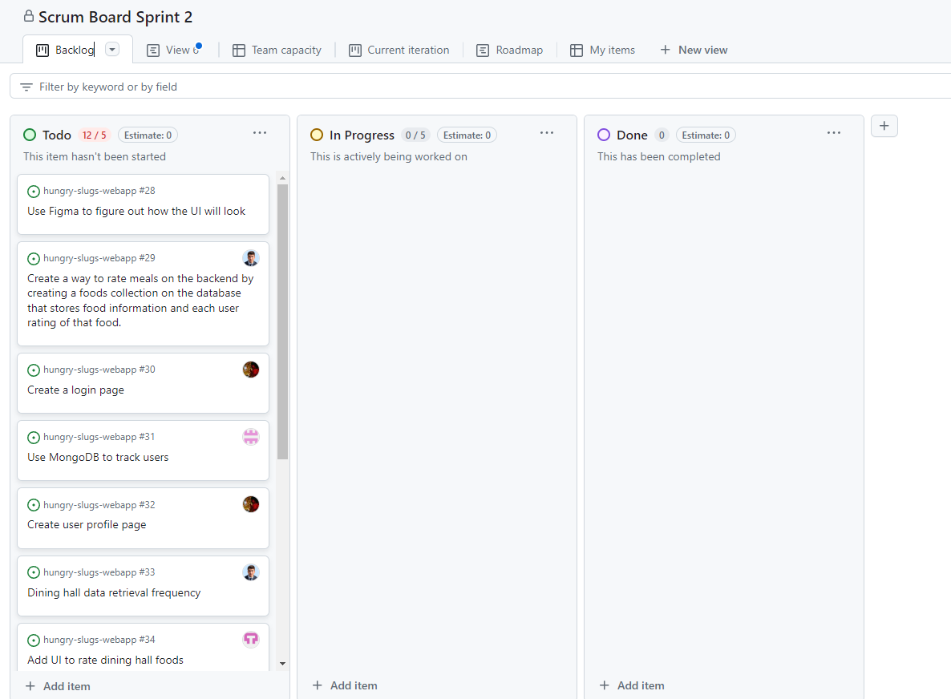

∙ **Scrum times:** List at least the three days and times during the week when your team will meet and conduct Scrum meetings. Also, indicate which of these meetings will have the TA/tutor visit as arranged with the TA/tutor. It is expected the TA/tutor will visit during the Scrum meeting during your lab time.

1. Mondays 11:00am – 12:00pm, Zoom with TA
2. Wednesdays 9:05am - 9:20am, with team
3. Fridays 9:05am - 9:20am, with team